
ATAR Biology

Unit 2: Topic 1
Week 18 – Microscopy


© SIDE

Student Study Notes

Unit Content
- Developments in microscopy and associated preparation techniques have contributed to more sophisticated models of cell structure and function.
- Conduct investigations, including microscopy techniques, real or virtual dissections and chemical analysis, safely, competently, ethically and methodically for the collection of valid and reliable data.
- Select, construct and use appropriate representations, including diagrams of structures and processes, and images from different imaging techniques, to communicate conceptual understanding, solve problems and make predictions.

Microscopes and cell size
Cells are the smallest independent units of life and vary in size and function. A measurement smaller than millimetres is used to estimate cell size. This unit is the micrometre (μm).

1 mm = 1000 μm

Cell size ranges from 10–100 µm for eukaryotic cells and even smaller for prokaryotic cells such as bacteria.

Field of view
The size of cells viewed under the light microscope can be estimated if you know the diameter of the field of view, which is the circle of light that you see when you look through a microscope. Changing from low power (LP) to high power (HP) increases the magnification.

As the magnification increases, the field of view decreases. For example, if you increase the magnification from ×100 to ×400, the field of view would be reduced to ¼ of its original size.

An estimation of the diameter of the field of view at low power (LP) using a clear plastic ruler is shown below.
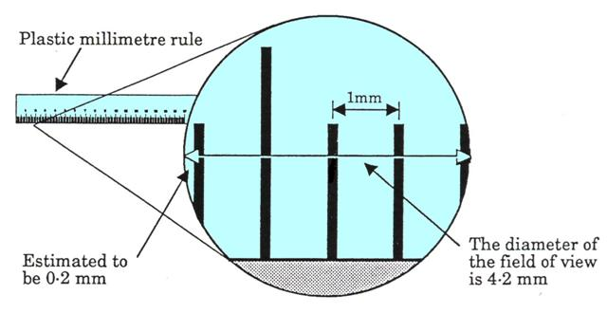
© SIDE

Now that you know the diameter of the field of view under LP, you can estimate the size of cells.
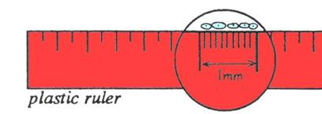
© SIDE

To estimate the size of an individual cell, count the number of cells across the field of view then divide the diameter of the field of view by the number of cells.

For example, if four cells fit across a field of view with a diameter of 4200 μm, each cell would be 4200/4 = 1050 µm in length as shown below.

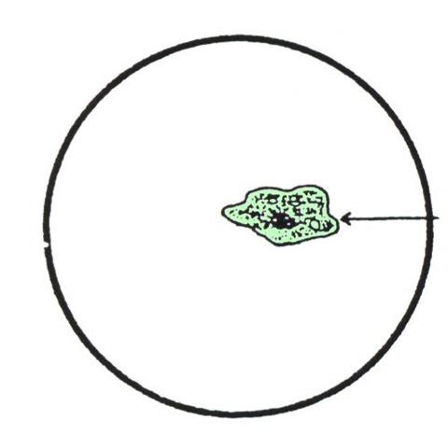
© SIDE

Objects viewed through the lenses of a microscope are inverted and reversed as shown in the diagram below.

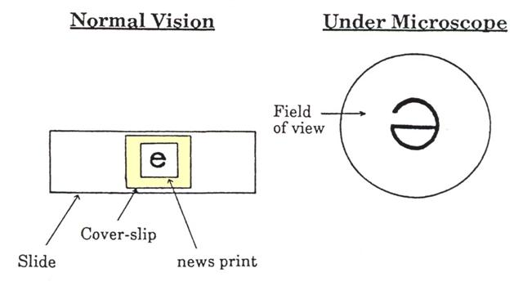
© SIDE

PRACTICE QUESTIONS:
Use your lesson notes, textbook and additional research to answer the questions below.

1. Calculate the total magnification using the information in the provided in the table.

 | Eyepiece  [Ocular] | Objective lens | Total  Magnification
Magnification of Low Power  MLP | x10 | x10
Magnification of High Power  MHP | x20 | x40

2. In the diagram on the right, the average cell length is 200 µm.
a) Estimate the diameter of the field of view.
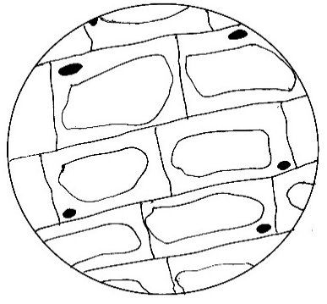

© SIDE
b) If the original x10 eyepiece is changed to x5 and the objective lens is unchanged at x10, would an observer see fewer or more cells across the diameter of the field of view?

3. Convert the following units to micrometres (μm).
2.4 mm = 0.2 cm = 4.2 mm =

4. Label the microscope below.
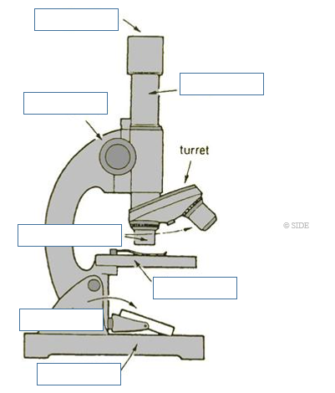

Source: Academic Task Force Sem1&2 2019
A student set up a microscope with a 10 X objective and a 10 X ocular lens.

- What was the magnification of her microscope?

- 20 X
- 100 X
- 55 X
- 600 X

- Using the magnification identified in Q5 she could count 12 epidermal cells from left to right across the field of view. In an effort to see the cells more clearly, she replaced the ocular with a 15 X and moved the 40 X objective into position.

How many epidermal cells could she now see across the field of view?

- 2
- 12
- 18
- 54

The diagram below shows an image of a mitochondria.

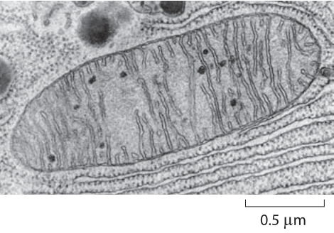
- What measurements best demonstrate the mitochondria’s dimensions?

- 2.0 μm x 0.6 μm.
- 2.3 μm x 0.8 μm.
- 2.8 μm x 0.9 μm.
- 3 μm x 1.1 μm.

8. Complete the table below.

 | Lens combinations |  | Total magnification | Field diameter mm | Field diameter um
LP | X10 | X10 | X100 | 1.25 | 1250
HP | X5 | X60 |  | 0.41
HP | X10 | X60



9. Describe three differences between light microscopes and electron microscopes.

10. The microscope is set up with an eyepiece of X10 and an objective of X10. The objective is then changed to X40. Use the word ‘increase’ or the word ‘decrease’ to complete each of the following statements about the change.
a. The diameter of the field of view will
b. The depth of the field of view will
c. The magnification will
d. The resolution will

11. Imagine that you used a light to look at the letter b (lower case). In the spaces below draw the letter b (lower case) as you would expect to see it under X4, X10 and X100 power. The circle indicates the size of the field of view.

x 4 x 10 x 100
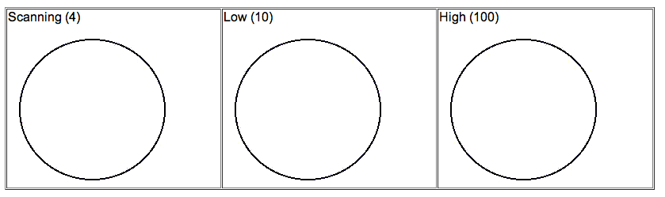

12. Adding a dye or stain to a preparation of cells under the microscope can be used to show clearly some components of cells. This is done without lifting the cover slip in a process called irrigating the slide. Explain how this is done. (4 marks)

